ANGELO MENDOZA BSIT-2C

# Representational Art - The Development of Representational Artworks Representational art Non-Representational Art

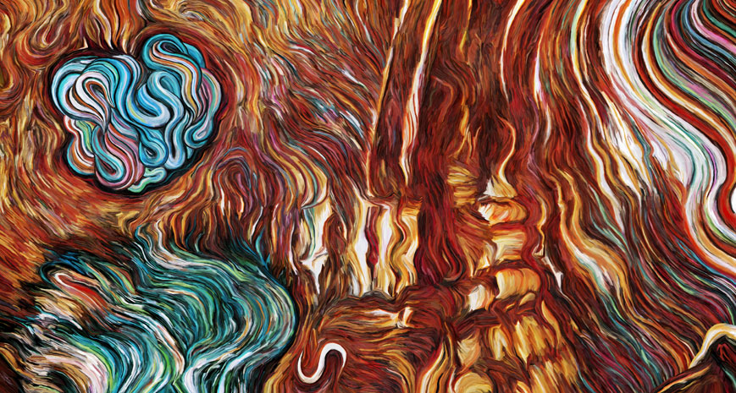

|  |  |
| --- | --- |
| By *Leonardo da Vinci*  The Mona Lisa has also been interpreted in different ways by different cultures. In Italy, where the painting originated, it is often referred to as La Gioconda, which translates to “the joyous woman.” This interpretation suggests that the painting is a visual representation of happiness. | By : Eric Wayne  While there isn’t anything  in the image that is intended to look like anything specific that exists, the self-entwining globule in the upper left evokes a consciousness. Overall it conjures an intelligence fluctuating between interior and exterior, dissolving and becoming, separation and integration, and all the while interacting with other apparent selves in a realm of flux. |